

FORSIDE FOR INNLEVERING

TILGJENGELIGHET
 | Fri |  | Begrenset

Emnekode og emnenavn: | Hovedprosjekt (PJ6000-13)
Tittel norsk: | Hovedprosjekt
Tittel engelsk (Hovedprosjekt): | Hovedprosjekt
Eventuell oppdragsgiver: | Syncrotec [2]
Utleveringsdato: | 6.01.2014
Innleveringsdato: | 21.5.2014
Antall sider:
Antall ord:
This is the project report to group 10 at NITH. It consists of in detail information about our current bachelor game project. The main focus of this document is to keep information about the game (rules, graphics and gameplay) and how we work on the project up to date as well as easily available.

Gruppenummer: | 10
Studentnavn: | Studentnummer: | Signatur:
Andreas Engebretsen | 700542
Aleksander Hougen | 700633 | 
Geir Haugen | 700579
Geir Inge Hillersøy | 700458
Jonas Dyrkorn | 700116
Studentens signatur er også en bekreftelse av at hun/han har gjort seg kjent med, og fulgt, NITHs retningslinjer for intellektuell redelighet (tilgjengelig på intranett).

Innhold
Hovedprosjekt (PJ6000-13) 1
Introduction 1.0: 2
Vision 2.0: 3
Goals 2.2: 4
Concept 2.3: 5
Concept analysis 2.4: 6
60 seconds of gameplay 3.0: 6
Challenge Highlights 3.1: 7
Balancing 4.0: 8
Prototyping 4.1: 9
Testing 4.2: 10
Testing analysis 4.3: 12
Market analysis 6.0: 14
Store guidelines 6.1: 17
Rules 6.2: 18
Post Mortem 8.0: 18
References 9.0 (In order of appearance) 18
Attachements 10: 19
GUI : 20
Sprint Reviews: 21
Drawings: 24
Visual themes: 25
Units: 27
Buildings: 28

Introduction 1.0:

We are group 10 and consist of Aleksander Hougen, Andreas Engebretsen, Geir Inge Hillersøy, Geir Haugen and Jonas Dyrkorn.

We have through NITH [1] gotten the opportunity to develop a game for a company in Oslo by the name of Syncrotec [2]. They want us to develop a release ready game for the application market. This will be a step by step process that will have frequent user tests and a high amount of vertical slices to keep up our tempo. Having this high amount of testing gives us the edge in balancing and time to improve the game as the project pans out.

To do this we are planning our work by using such tools as SCRUM [3] and
Jira [4] as well as using Google drive [5] and GitHub [6] for version control and documentation. We will have meetings with both the external and the internal counselors when needed, as well as giving them all access to relevant documentation for feedback. An important part of our design process is to not only create a game that can be monetized, but at the same time analyze the current marked and design our game with the intent to improve on current trends for design and business model implementing different ways of testing and creating personas that we will learn through our other courses and using it to benefit our project will also be an important part of the game.

The game we envision is a tower defense type of game with something we see as a new twist, the game is intended to support multiplayer, and have new gameplay elements mixed in to give it a fresh taste. This document will contain what we would consider to be our game in written form.
It will also contain reports, analysis of different aspects of our game and process and testing.

Vision 2.0:

The original plan for the game was to implement it for the platform Tapas play that Syncrotec [2] owns. This idea was abandoned for a standalone game. This game is meant to be an income source for Syncrotec [2], where the money comes from in game purchases. We want to keep the game free and completely playable without using any money, but make it tempting to use money to ease the time and investment. Therefore we will look at the more successful business models and try to create our own model that will benefit our game.

As we want to create this game for the mobile market we want our gameplay at the utmost simplicity, and rather give the player complexity by choices and options in the Meta game.

By analyzing the marked we will try to create a game that has potential to become popular based on the results from this analysis. We intend to design and create our own assets and textures from scratch. We will be doing different ways of testing to make we are making progress. In the early phases we will be doing testing where we will try to get as many people as possible to get an overall opinion on the game. The later testing phases will focus more on smaller groups of people testing specific elements in the game. Between the external testing we will be performing internal group testing within the group. This is important for the sake of keeping everyone up to date with the current version of the game.

Vision analysis 2.1:

Our vision was based on a mix of the wish of the company as well as based on our market analysis. Considering that the market today is having a huge growth when it comes to mobile games that are fast and easy to play. We felt that it would be a shame not to take advantage of this marked.

Having people with some talent in Photoshop [7] as well as 3d studio [9] we felt that creating our own assets would allow us to stylize our game just as we wanted to ourselves. The reasoning for designing this game with mobile platforms as a main focus is because of the huge growth in that marked. Considering that mobile games are usually played for very short amounts of time. We also wanted to focus on making the game enjoyable for short bursts at a time. We also have people with their own dedicated tasks. When we wrote our group contract we gave everyone certain tasks that they are in control over. This gives every member of the group a certain job that they will always be updated on and it also gives them a reason to keep working.

We are designing the multiplayer to be played in rounds that can be finished whenever the player feels like it. It is important for us to keep the single player functioning the same as the multiplayer component. The reason for this is that we want the player to feel familiar with the game mechanics and be able to jump right into the gameplay.

An aspect that we are trying to implement is teaching the player how to play the game without reading tutorials; we feel that the odds of gaining more players will grow if the main aspects of the game are simple to understand.

Goals 2.2:

Our goal is to design and develop a fun and creative game experience where skill based gameplay is the main focus. Throughout consistent testing and iterations to create as good a game as possible. If possible we will try to develop a second small game, but this is only a possibility if we completely finish the first project.

We intend to create our own assets using tools such as Photoshop [7] for a more personalized feeling. Another goal that we find important is to re-define the genre we are working within in an attempt to change the basic formula of the tower defense game type. Another goal for this project is to integrate our game with the already existing web platform that is Tapas Play [8] and develop our game so that it can be played by two people competing against each other without having to do everything in real time. This allows the players to take their time planning their next move before ending a turn. We will also work hard on keeping the game balanced and the balancing will go on throughout the entire project.

We are prepared if needed to cut certain aspects of the game if needed to be able to finish the game. Some aspect of the game are still being put on hold until we can find a way to put it in the game and at the same time keep everything feeling balanced.

Concept 2.3:

Our concept is a Tower defense type of game mixed with a city builder. This means that we will take the defend your base type of gameplay to a whole new level. You start off with a main building (Town Hall). This building represents your life and if it is destroyed you will lose the game.

The tower defense part of the game is made up by placing towers next to a road leading into your base and stopping the enemies from advancing too far. The city building part will be fairly basic to not confuse the player. It will be made up by having different areas around your town hall where you can place buildings of your own choice. These building will range from money upgrades to giving you different units to use.

You will be free to choose what building you would want to place so that the player can decide what kind of strategy he or she would want to use to win the game. We will introduce a competitive multiplayer system where instead of real time you will end a round and then the game will go on. The first player to destroy the enemy Town Hall will win. Our game will be set in the era of the Vikings and we will use designs from that era, such as churches and Viking style of armor, towers and weapons. Even though we will follow this kind of style we will also have creative freedom to add our own little touches to the old designs, The reasoning behind this is that we want to adapt them to our certain style as well as making them somewhat more fun to look at, but still we will try to stay true to the source material and not drastically change it.

Concept analysis 2.4:

We chose to base our concept around Tower defense as well as City building because of the fact that these are two very popular types of games in the different stores on mobile devices, but combining them is still a new genre. We intend to take the basic aspects from both games and combine them into a new fun experience. By not having real time multiplayer we avoid the problem of having server lag that would otherwise ruin the gameplay experience. We were informed by the company we work for that lag has been a concern in other games they had developed and we took this into consideration from the very beginning.

Looking at the mobile market we also decided on a more cartoony style to suit a larger audience. We will also adapt a simple yet colorful style when it comes to our GUI so that it will be easy for users to navigate and play the game. An important part of our concept is that we don't create something to similar to other known games for the sake of not being sued. We will have to be careful when it comes to the design and feel of the game to avoid this.

Even though our main goal is a fully functional multiplayer, we also have a backup plan in case the net coding turns out to be more difficult than expected. We have tried to think ahead by giving our programmer six weeks to make it functional. If for some reason it won't be functional at release we will make the game single player and remove the multiplayer. Instead of battling another player you will now battle an AI.

60 seconds of gameplay 3.0:

The second wave of enemies is defeated and now the user have a new build phase, the user saw the opponent used a lot of heavy’s, and responds by upgrading the area of effect tower into an anti-heavy tower then selects jumpers from the barracks to counter the basic tower of the opponent. The user presses ready to start the next wave, the jumper moved swiftly past the opponents basic tower, and the anti-heavy upgrade did its job, if only the opponent didn’t build spies this would have been a good round.

Challenge Highlights 3.1:

An important aspect of the design is having the player feel like his choices when it comes to building have an effect on the gameplay itself. Not forcing the player to follow a certain strategy allowing them to create own strategies. The challenge in this is that the players will have to figure out what works the best for them through trial and error, but at the same time we want to make any strategy viable when applied correctly.

It is important for the design of the game that we don't force the player down a certain path, but instead that the player tries to forge a path of his own.

The city building element of the game allows the player to choose how he wants his towers and units to work. The way the player decides to build will eventually reflect back on the results from the round. We will have 3 main units and 1 specialty unit that the player will have to defeat. The challenge from this will be that some tower will be efficient against certain units while less effective against others. Another aspect that will challenge the player has to defend against several different paths on some levels. The player will have to place his towers in a way so that he can be somewhat effective on both paths. By focusing on only one path the player will let some enemies slip through.

The units will also have certain attributes that make them unique. The basic unit will be easily defeated by the basic towers. The jumper unit will need a special tower that can bring him down from the jump. In this lies the challenge considering that the anti-jumper tower is only effective when it comes to bringing down the jumper.

The player will have to balance how he builds the towers so that he can find a balance between damaging and slowing down enemies. The player will also find a way to balance how he wants to upgrade his towers.

When it comes to the multiplayer component to the game the challenge will have similarities, but will also require some strategic thinking. The main difference between multiplayer and the single player component is that the other player chooses what enemy types you will face. The challenge here will be to try to find a balance between defending against the enemy’s troops as well as sending out special troops for yourself.

Another important aspect is to try to find you opponent’s tactic when it comes to building troops and then create your own tactic to overcome him. The players will have to try to get as much done as possible before ending a round to maximize his defense as well as the offense.

Another challenge is to adapt to the different kind of players that you will face. Some will play more aggressively and spend their money on units while other may be more defenses and spend most of their money on developing buildings and towers. Finding strategies against all the different types of opponents will the key to winning.

Balancing 4.0:

When it comes to balancing there are several things that we will have to do. The towers need to be balanced against the waves of enemies and they need to be correctly priced when they are bought or upgraded. How much money the player will earn per round and how it will scale with the more difficult rounds will also be important to balance so that the player does not feel cheated by the game. By getting your units into the enemies base in multiplayer will award you some more money for the next round. The balancing itself will start from the first external testing.

The balancing itself is something that will be ongoing throughout the entire project and will never really be done. Finding a way for the spy to function in a way that does not add a dominant strategy will be a difficult task. We are not entirely sure on how to design the spy yet. We will have to decide if this is to be a killable unit or a type of active ability. We are working hard on removing any kind of ability for the player to manipulate stats in order to dominate a game.

Prototyping 4.1:

In the first two weeks of developing an idea for the game, we went through several concepts.
We made prototypes for the concepts that we liked the best.
While looking at the different prototypes and the concepts, we chose ONE concept with the consent of Ståle and Eirik.

We made complete prototypes of two of the concepts.
One of the games we made a prototype for was a game where you shot a mole down into the ground. While the mole dig its way downwards, you have to steer it to collect treasures, avoid obstacles and eventually reach the goal at the bottom.

We also created a detailed prototype for a game we called “Brong” which is a mix between Pong and Breakout for two or more players. We left this concept because real-time gameplay between players is not possible in the way we designed the concept.
After going through four to five prototypes and having a meeting with a vote at the end of it we settled down on creating a tower defense game with a new twist. We could by doing this get around the obvious lag problem.

Our first Tower Defense prototype was a simple attempt to get the basic functionality going. We wanted to see how difficult it would be for our programmers to grasp Unity and its features. After a short learning period we had a functional prototype up and running with basic graphics and basic functionality. This gave us a chance to see what would possibly become a challenge later on in the project.

What the group feels will be a difficult part of the project is the network coding later on in the process because of its complexity with Unity [10]. At the same time we feel that AI could take time, but we have taken these things into consideration at planned extra time when it comes to developing them. We tested the first prototype internally on a phone in order to see if scale and animation was functioning as intended. We will need to tweak the path finding somewhat, but overall the test was a success and everything felt visible and simple to understand. When it comes to our externally tested prototype we went for a more complete design. We designed a map up to what we consider production quality to avoid having the tester focus on the look of the game over how it played.

We decided not to add all the gameplay elements in this prototype and instead focus on the basic tower building part of the game. Things such as sending units to the enemy base and city building will be iterated for later prototype testing. By doing it like this we can focus our tests at certain aspects of our game at a time instead of having several half-finished parts of the game at once. This also allows us to do a more detailed internal testing when it comes to the new gameplay elements before we do the external testing. Our first main testing will now consist of changes that we made based on the feedback we got on our google tower defense based questionnaire. The changes will be subtle, but important as it will give us an overview of how a tester feels about our current build. The build for sprint three was a lot closer to what the final build is to look like. It had all of the basic gameplay elements completed and was played on a phone. This prototype gave us an even clearer goal when we start work on the next iteration of our game.

Testing 4.2:

We will perform several different tests throughout the project to test the gameplay and design of the game as well as getting feedback from a wide array of users. Our initial test will be mostly focused on basic gameplay and graphics. We find that it is important to start off with this kind of testing simply to see if the player finds the game fun and that it is not confusing or difficult to understand.

We will design and create as close to a production quality map for the first proper external testing to avoid having too much feedback about it not looking finished. At the initial testing only the basic gameplay functions will be present so that we can focus on testing new things in later iterations. We will detail questions in a questionnaire for the testers to fill out where the questions will focus on how the player felt that the gameplay was moving forward and if he or she picked up some of our visual cues. If possible we will perform tests on both mobile and a pc, but we feel that if we can only find time to do the initial test on a computer it will suffice for this iteration.

When it comes to selecting testers for this prototype we will try to get a variation of people. From those who play these kinds of games on a daily basis to people who have little to no experience playing games. We intend on creating a game that anyone can play even with little to no experience without having to read through a long tutorial.

The testing will be performed with one of the developers sitting next to the tester observing as well as giving aid if the player gets stuck or has a specific question. The developer will also be taking notes of the test process itself in case he notices certain behaviors from the tester.

After the test has been completed the developers will gather the data and analyze it, looking at what the player like, disliked and wanted different. We will then re-iterate the game and perform changes based on the feedback before our next testing phase. As the testing goes on we will start testing on mobile devices to see if our game’s assets are correctly sized and if text is readable on a wide array of devices. We will if possible do some straight up design testing were we show of different iterations of our concept art to receive feedback on what suits the game the most.

After a session of internal testing we discovered that we can lower the resolution of most of the assets. The way they look now, with the current resolution adds to the overall size of the game by a lot. When playing the game on a mobile device you won’t need as high a resolution as if you were on a pc. The resolution is currently set to a point where you could zoom all the way into the map and all of the characters and towers are sharp and clean. By changing the resolution we will shave off several MB from the install size.

We will consider letting the player choose his own resolution when playing on a pc. Our main focus is to make the game functional and fun on mobile devices before moving to the pc. The reasoning behind this is that we feel that it is smart to start out on the most simple platform and then port it over to something with more buttons later. After the questionnaire part we have a long list over the most common phones. This gives us a clear idea over what devices we should optimize our game for.

We took some time to do some interviews to get an overall opinion on the tower defense genre as well as some useful feedback on the art of our game. We discovered through this process what people are looking for in these games and what they feel is less important. The biggest change we will have to do based on the feedback on these interviews is to overcompensate when it comes to our character art. Most of the people interviewed did not recognize the Vikings and though they were animals or goblins.

Testing analysis 4.3:

We decided to focus our testing on simply showing our prototype to people and then have them answer a questionnaire. The questions were Tower Defense based and served to give us an idea on what phones people use as well as what games they prefer to play. The answers were for the most part quite useful and brought us information that can be used when it comes to developing our game. Some of the answers were “funny”, but we knew that some would not take it seriously and because of this we tested some extra so that the joke answers would fade out by the amount of answers.

An important question was about the mobile devices that people use. We find this to be important for later external testing, we will use this information to know what phone is the most used so that that we can work on making the game as compatible as possible.

Most of our testers were IT students, but we also have some students within other studies as well as people who are done with their studies and are now working. There was also a good mix between people who play games on a daily basis as well as people with little to no experience when it comes to games. This gave us a huge variety of answers.

Overall most of our testers have modern phones, but we will still have to cater to the weakest phone in the list so that the game is functional for most people. When it comes to time spent on games such as the one we are creating the answers were fairly surprising. Most of the people said that they would spend up to two hours in one sitting. The average playing time for most mobile users is known to be from one to 10 minutes in one sitting.
What seems to be important for most of the testers is fast fluid gameplay with little to no interruptions during gameplay.

When it comes to sound it seems that this is little to not important for most of our testers. This was something we knew as most people tend to play with their phones on silent. Even though sound may seem to be unimportant for most people, we will not neglect the sound environment for our game The sound itself won’t be our main focus until later on in the iteration process, but we will try to make it sound good enough to make people actually turn their phones volume up to listen at least a little bit..

Most of the users find that the graphical style of the game is crucial to them actually playing it. The style that most people like is a cartoony look as well as a clear distinction of what all of the different objects within the game are supposed to resemble. As we expected no one likes ads or micro transactions within their games, but some agreed that ads are fine as long as they are not shoved in your face constantly. We will look into creating ways for micro transaction to be not to gameplay changing and to instead have more cosmetic effects. When it comes to historical settings it seems to be very varied what people would want. Some said Vikings while other want medieval. Overall the difference between these two when looked at from above is minimal and we feel we can make both sides happy with our design.

One of the testers wanted an in progress save function so he can continue his single player game from the last played point. We find this to be an interesting idea and we will see if we can find a way to incorporate it into our game. We will do some more in depth testing to see what people feel about our graphical style as well as the pace of our game as often as possible to be able to modify it accordingly. We are currently preparing for a gameplay test where our main focus will be to see if people actually enjoy playing our game. A reason we decided to do the questions before the testing of the game itself was so that we could do some modification of our game based on the answers.

Market analysis 6.0:

Looking at the current marked today shows that within the tower defense category the most popular games are built up with colorful graphics and usually cartoony characters to appeal to a broader audience. The games themselves are built up to be playable with one finger in order to keep the interaction with the game as simple as possible. We have decided to adopt the cartoony and stylized type of design to appeal to a broader age group as well as both genders. We will adapt the trend of using color in the game. This gives of a positive type of feedback to keep the player satisfied about the things he or she achieves in the game in order to keep the player interested. We chose the cartoony graphical style because of it being the most popular style when it comes to games on mobile platforms. The cartoony style is also more appealing to a greater audience. Also making the “violence” less violent by removing blood and anything that may decrease our user base is an important task. Changing the blood into a puff of smoke or something similar. Removing violence is also a good addition to our cartoony style. Another important part of designing the game is to keep the design modern and clean to give the user a more comfortable experience using the game.

By analyzing what is currently popular and used by bigger developers we will adapt our game to follow a similar style. Looking at these different developers we have noticed that what is currently popular is clean non sharp colors as well as simplicity. Designing our game this way will allow users to quickly adapt and feel at home playing our game. Our main design choices come from what we consider to be the closest thing to our game concept and that game is called Kingdom Rush [11]. We spent quite some time playing and analyzing the game and its rules in order to see what we felt made that game so much fun, but at the same time how we could improve on their design and gameplay choices.

Looking at different business models was also an extremely important part of our project because of the amount of different ways to monetize on a game. While the intent is to make money of our game we feel that it is important to not make the user feel like he or she has been cheated because that while turn the user base against us. Our business model will be a version of the popular freemium model. This means that while the game itself will be free to download we will give the players a chance to buy simple upgrades or cosmetic skins to change the look of your game. By having a business model where the player can play through the game without feeling that he has to purchase items to complete the game is important to keep the player coming back for more. Looking at the current most played game on mobile platforms “Candy crush” [12].

The game itself is free and it is though difficult possible to play through the entire game without having to purchase any items, but in between levels you are given that option. It also does very well when it comes to integrating your friends into the game by Facebook [13] sharing and the possibility to give friends more “life”. Their way of making it simple and quick to purchase help for the game at any time without making the player feel like he is being forced to purchase anything. By doing this they are building up trust and at the same time they are making their users feel comfortable with using their product. Looking at a game that is quickly becoming the biggest mobile game of 2014 “Flappy bird “[14]. The game itself is completely free and has no monetizing except for simple ads in the game. The game itself was released 2013, but is just now becoming known. Even though the developers are not making any money on the game itself the sheer popularity of the game has almost made sure that their next game is going to be noticed, so that they could in theory monetize well on their next game based on their Flappy Bird’s [14] success.

Another thing that is incredibly important when you design a business model is not only to look at what we consider good business models like the ones from Candy Crush [12] or Angry birds [15], but at the same time look at companies that have notoriously unfair models. An example of this is the new Dungeon keeper [16] game for the mobile platforms. The game is running what many consider to be the a terrible freemium model where the game is constantly pushing its model in your face to make you buy “gems” that will make everything build faster. This is a game that cannot be played efficiently without buying these gems because of the time it takes to do anything in the game. Some things take up to 24 hours to build unless you spend 8$ for the gems needed to it instantly.

It is important that we analyze these kinds of models so that we can avoid making such a mistake where our user base feels cheated by our model. Another thing that is important is that because of the huge growth when it comes to models like this if we can have a good model in between the terrible ones we will gain the trust from a user base that is growing tired of these kinds of business models. When it comes to tempting users into trying our game an important aspect is the icon that they will see when going to the different stores. Looking over the current popular games there are certain trends that are being repeated.

The use of certain colors and fonts make the different logos seem more appealing to the eyes and we want to find a way to implement this for our game. When it comes to finding a name for our game the importance of something that people can instantly remember and the name itself should be connected to the gameplay. By doing this we let people know what our game is subconsciously. By pulling in people’s interest by using psychology is a common thing and it is important to use it subtly to not make the users feel like we are trying to cheat them.

Another aspect that is important when it comes to making the players enjoy and come back for more is the sound aspect of such a game. Looking over such games as Candy Crush [12], Flappy Bird [14] and Angry Birds [15] they all seem to follow the same theme. Even though their sounds a simple and minimalistic they are never sharp or unpleasant to listen to. They are very subtle, but at the same time they enhance the game experience by giving the player a good amount of positive feedback. Even though most players won’t think about the sound it does affect how long they will play the game without becoming tired.

Store guidelines 6.1:

An important part of publishing a game on the different stores currently available is to make sure that we don't break any of the rules set by the respective companies. Currently we are analyzing the App store [16], Windows store [17] as well as the Google play store [18].

Even though the stores have most of the same guidelines [18 app store]
[19 Google play] [20 Windows store] there are some subtle differences. Because of the fact that our game is free and ads are important for the monetization of the game we need to be careful not to break their guidelines for ads or certain types of content.
Because of these guidelines we have decided not to have certain elements in our game.

Blood and any kind of violence is removed and because of apple’s guidelines [18 app store]. When it comes to simplistic and simple to use GUI we will have to create something simple. The guidelines also specify on how we are to place ads. It is important to not have ads in locations where they could be accidentally clicked by a player. An option to this is to only show ads when the player is in the menus. We might have to be careful when it comes to having shirtless Vikings considering that both stores are relatively strict when it comes to having too much skin showing. if it comes to this it won't be much work to fix the character drawings.

Overall there should not be too many issues with our game when it comes to the different policies, but we are trying to be prepared for the different things we might have to change.

Rules 6.2:

Since the game is turn based (make towers/buildings/upgrade step, and unit attacking/ tower defending step), The game will grant the player an amount of resources to spend for each building phase, this amount can be adjusted for each wave making it faster paced, or make it possible for the user to hurt the enemies amount.

There are restrictions on where you can build towers, this is in place to streamline the game in some form, and this rule also applies to the buildings in base. The main objective is to keep your town hall living after a set amount of waves.

You will lose the game when your town hall is destroyed by the invading force. When all waves have been defeated you will move on to the next level or if it is an online game you will move on to a new opponent or have the opportunity to have a rematch. you will gain money by taking out your enemies as well as winning rounds. With the money you earn you can decide what you think you should spend them on from new towers to tower. As for the multiplayer aspect of the game we will have turns. This means that both players will plan their defense and offense and then they both have confirmed their moves the game will progress. There will always be a default group of enemies that will move out from both sides to not stop the game, but players can choose to send out certain enemies. The players will have to decide on if they want to focus on a heavy defense or a heavy offense. The last player with a town hall will win the game.

Post Mortem 8.0:

References 9.0 (In order of appearance)
http://nith.no
http://www.syncrotec.no/
http://no.wikipedia.org/wiki/Scrum
https://www.atlassian.com/software/jira
https://drive.google.com
https://github.com
https://www.tapasplay.com
http://www.photoshop.com/
http://www.autodesk.no/products/autodesk-3ds-max/overview
https://unity3d.com/
https://www.facebook.com/
http://en.wikipedia.org/wiki/Flappy_Bird
http://www.candycrushsaga.com/
http://www.angrybirds.com/
http://www.ea.com/dungeon-keeper-and
http://www.kingdomrush.com/
https://developer.apple.com/app-store/review/
https://itunes.apple.com/no/genre/ios/id36?mt=8
http://msdn.microsoft.com/en-us/library/windows/apps/hh694083.aspx
https://play.google.com/store
https://developer.apple.com/app-store/review/
http://developer.android.com/distribute/googleplay/promote/brand.html
http://msdn.microsoft.com/en-us/library/windows/apps/hh694083.aspx

Attachements 10:

Creating a building:
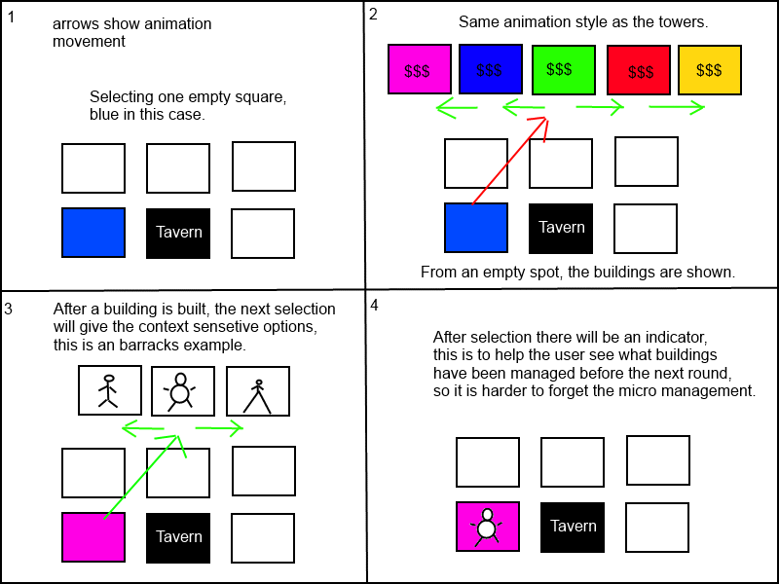

GUI :

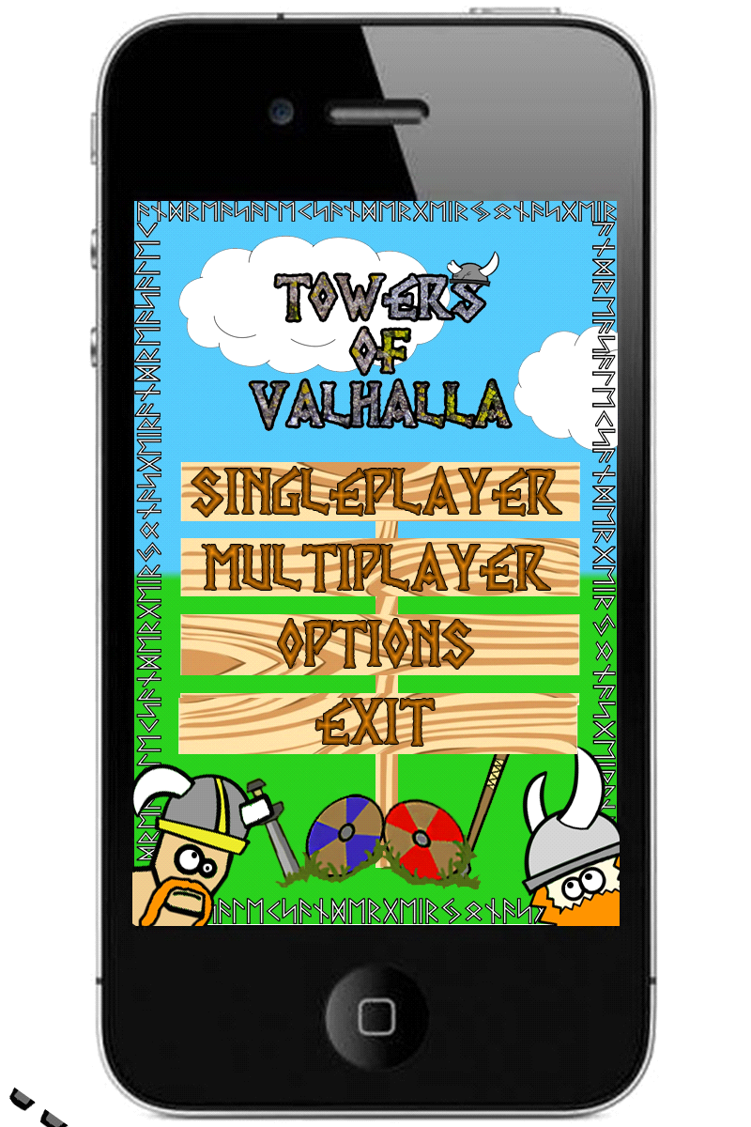

This is an example of our first “Sketch” of a main menu. The colors and fonts are not yet complete, but it gives us an idea of what we want the graphical style to be like. The color of the title will be changed to give it a cartoony look. The grass and sky areas will have more detail. We are also not done deciding where to place our Vikings. We want our design to be cartoony without giving our game a “childish” look. The final version of our main menu will have more assets as well as redone text and backgrounds. Testing has shown that we will have to edit the font to make it more readable. This will be done in the next iteration.

Sprint Reviews:

Sprint review for the first two weeks of our project. We spent most of the two first weeks of the project paintballing ideas between each other and trying to see what we actually could do with the time we were given. We drew up four to five “main” ideas that we talked about within the group. After this we had a meeting with the company we would be working for to see what they felt about our ideas and how we were to accomplish them. We gave yourself one more week of brainstorming to see if we could keep the idea momentum going.

During this week we tried coming up with simple yet fun games that would be doable within our timeframe. We had to abandon some ideas because of the fact that they were either too similar to other famous games or that we felt that they would not be fun enough to last in the long run. There has been some discussion in this part on how we are to do the business model without losing the players interest. We did a in depth market analysis in order to take points from mobile games that have what is considered good models as well as the more known bad models.

At the end of the second week we had yet another meeting where we pitched the new ideas as well as showing off some prototypes we made to give a more visual representation of our ideas. We came to the conclusion that we were to make a tower defense game with a new twist.
We started off the next week by designing a basic proof of concept where we had some simple towers and moving enemies. The group dynamic was working well because of the fact that we all knew each other before we started.

We had assigned main tasks for everyone so that everyone had a main area of expertise. Because of this everyone knew what they were doing at each time. So far the daily stand ups have been useful for keeping everyone up to date with what is being done. We have set up a Jira [4] account with an extensive backlog in order to keep everything under control. So far we feel that we are somewhat ahead of schedule when it comes to that game itself. The programmers understood Unity [10] faster than we had though and this has lead to a much more detailed second prototype than what we anticipated.

We are currently working hard on getting the game ready for our first official external testing. For this test we are planning to have a production quality map with the basic building and defending. We decided not to have every feature in this iteration.

At the end of iteration two we have gotten a lot of assets and back end coding done. The documentation has gotten quite a lot longer and detailed. When it comes to the testing we have decided to postpone it to the end of the next week so that we can make the prototype even better. As of now the things we will have to improve on is to get everybody to meet up at the correct time, but we are improving on this. Overall we are quite content with our progress on the iteration and we expect to do even better on the next iteration.

When it comes to the third iteration we have made small but important improvements to the code. Most of the work that has been done has been oriented around repairing broken code and doing basic testing. A big issue with this iteration is that we made some big mistakes when it comes to the game coding and we had to redo a lot. We have improved on the aoe rock so that the smaller pieces of the rock also do damage to the enemy. We have begun on the code that lets units attack each other. When it comes to the artwork we have finished several important towers and buildings, they will have to be animated in the next sprint. We also finished a demo map that we showed off to different people at the school and received feedback on design.

We are currently trying out ways to add a save game function in our game. We decided to push the external testing back one week so that we can finalize the features we are currently working on.
In iteration four we made the biggest changes to the gameplay. The external testing this time was done on mobile phones. The testing focused on the graphical part of the game, as well as the new main menu. We felt that it was important to external testing on phones in this iteration. Testing our game on phones gave us valuable feedback on size and visibility. The testing showed that we need to make certain changes to our units, towers and GUI. The main changes we will have to make are the size of our units. Testers felt that they were a bit small and we will need to make them somewhat larger to compensate for a smaller screen. There will also have to be shadowing added to the towers and units to make them look less flat.

Overall we feel that we got a lot of work done in this sprint, and that we are closing in on finishing the back end portion of the project. This means that we soon can start polishing and mas develop maps for the game. We are also closing in on the biggest portion of the development, which is the network coding. We have given our programmers six weeks on this considering the size of this part.

Drawings:

This section is to show drawings that were used while creating the game, not always the best art but to show ideas in a quick form, and share some temporary work for others to see. As pictures pasted here are not final, take it with a pinch of salt.

This section is also prone to change at any time as new drawings are made or old ones are updated. Some drawings may not even have descriptions but be basic layouts for something completely out of context for later use.

Sketch for balancing loops.
The five center black circles are the units, and the outermost black is the towers.
Will be redrawn better for easier understanding.

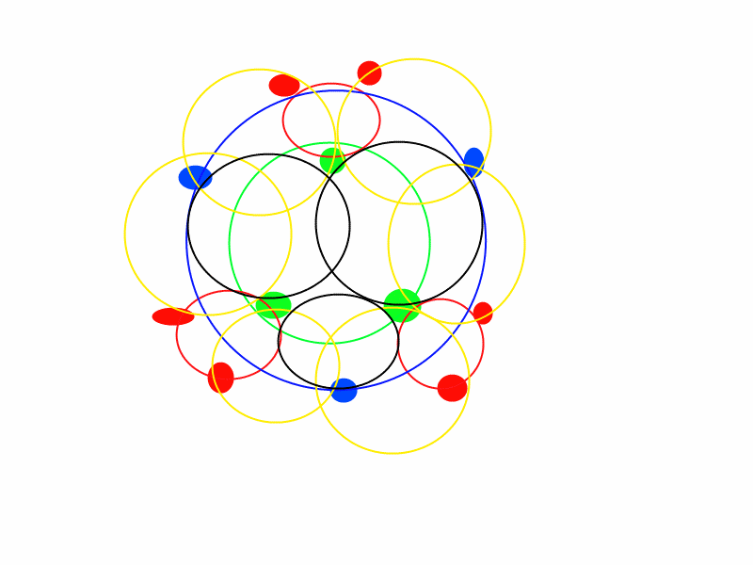

Visual themes:

Our game will feature different environments for the player to advance trough. We are currently looking at a forest like environment as well as a snowy winter landscape with ice cliffs and frozen lakes. We feel that these two environments in particular fits the theme we are going for. The contrast between the two different kinds of environments will give the player much needed variety so that they won't lose interest with the environments quickly. The themes also allow us to create some cosmetic assets to add variety to the environment. An important aspect of our design is to keep the games colorful even though they might be in environments that mostly consist of one color. We are working hard trying to add variety to these areas.

For our first external test we designed a frozen landscape for the player to test. Based on their feedback the design may be altered. An important part of the design is to make the map itself feel alive with cosmetic content.
this means that we will fill out the areas surrounding the path with trees, lakes and mountains, giving the world a more vibrant feel. It is also important that our cosmetic additions don’t distract the player or makes the player click on areas he is not supposed to. The artist has taken inspiration from other similar mobile games as well as Disney movies. The way the characters are being drawn gives them a unique hand drawn look which we feel is unique to the genre and will give our game a fresh look.

Main screen
-Menu
-Graphic
-Sounds
-Title
-Background animation?

Back end
-Music
-Save function
-Player to Player interaction
-Player to server
-User to shop
-Micro transaction interface
-Client to server

Towers:

Basic tower
-Graphic
-Projectile
-Sound
-Hit effect
-Animation
-Attacking
-Idle
-Upgrade tree menu
-Anti jumper
-Graphic
-Projectile
-Sound
-Hit effect
-Anti heavy
-Graphic
-Projectile
-Sound
-Hit effect

AoE tower
-Graphic
-Projectile
-Animation
-Attacking
-Idle
-Upgrade tree menu
-Anti scout
-Graphic
-Projectile
-Sound
-Hit effect
-Anti heavy
-Graphic
-Projectile
-Sound
-Hit effect

Slowing tower
-Graphic
-Projectile
-Sound
-Hit effect
-Animation
-Attacking
-Idle
-Upgrade tree menu
-Anti scout
-Graphic
-Projectile
-Sound
-Hit effect
-Anti jumper
-Graphic
-Projectile
-Sound
-Hit effect

Units:

Scout (Low health, Low damage, High speed)
-Graphic
-Animation
-Walking
-Hurt
-Doing damage
-Sounds
-Getting hit
-Doing damage

Heavy (High health, Medium damage, Low speed)
-Graphic
-Animation
-Walking
-Hurt
-Doing damage
-Sounds
-Getting hit
-Doing damage

Jumper (Low-medium health, High damage, Jumps!)
-Graphic
-Animation
-Walking
-Hurt
-Doing damage
-Sounds
-Getting hit
-Doing damage

Spy (Stealth, High damage, Medium speed, Low health)
-Graphic
-Animation
-Walking
-Hurt
-Doing damage
-Sounds
-Getting hit
-Doing damage

Buildings:

Town hall (used for health indication, and is the base structure of the game)
-Graphic
-three stages
-Good
-Some damage
-Close to destruction
-Health indicator
-Animation
-Spawning the basic unit

Barracks (Used to increase units produced to attack enemy, and uppgrades for the units)
-Graphic
-Three stages of health
-Good
-Some damage
-Close to destruction
-Menu
-Hire units
-Uppgrade units

Armory / Masonry (Used to uppgrade towers, and the building in the base)
-Graphic
-Three stages of health
-Good
-Some damage
-Close to destruction
-Menus
-Uppgrade towers
-Uppgrade buildings

Market (Used to affect the economy of the game)
-Graphic
-Three stages of health
-Good
-Some damage
-Close to destruction
-Menu
-Financial “spells”
-Icons

Tavern (Offensive upgrades to use against the enemy)
-Graphic
-Three stages of health
-Good
-Some damage
-Close to destruction
-Menu
-Abilities
-Icons

NSA (Used for special units and intel abilities)
-Graphic
-Three stages of health
-Good
-Some damage
-Close to destruction
-Menu
-”Spells”
-Icons
-Hire unit

